- Pick a recent trending topic from Instagram Reels or YouTube Shorts and write a 200-word blog post draft about it, making sure to include your chosen keyword at least 5 times.

Chosen Keyword: Instagram Reels Trends 2026

Instagram Reels Trends 2026: What’s Trending Now
Instagram Reels continue to be a popular way to discover new content, ideas, and entertainment. In 2026, creators are using new trends to reach more people and increase engagement. Popular trends include trending audio, creative transitions, relatable videos, and educational content.

Short and Authentic Content
One of the biggest Instagram Reels Trends 2026 is short and authentic content. Viewers often prefer videos that get to the point quickly. Creators are using simple stories, useful tips, and behind-the-scenes clips to connect with their audiences.

Trending Audio
Trending music and audio can make Reels more engaging. Creators use popular sounds that match their content and current trends. However, the audio should fit the video and feel natural.

Reels for Businesses
Businesses can also use Instagram trends to promote their products and services. Brands can create product videos, customer stories, tutorials, and entertaining content. These Reels can help businesses reach new audiences and build brand awareness.

Consistency Is Important
Following Instagram Reels Trends 2026 is helpful, but consistency matters too. Posting regularly, using relevant hashtags, and writing engaging captions can improve content performance. A strong opening hook can also encourage viewers to watch longer.
By combining current trends with original ideas, creators can attract new followers and build a stronger Instagram presence.

- Calculate the keyword density for the keyword 'discount' in the following Flipkart-style product description: 'Get the best discount on top mobiles. Discount offers available on Flipkart. Grab your discount now before it ends. Discount valid for today only.' Show your calculation and result as a percentage.<br><br><em><strong>Hint:</strong> Keyword density = (number of times keyword appears / total number of words) x 100.</em>
The keyword “discount” appears 4 times. There are 28 total words.
Keyword Density = (Keyword occurrences ÷ Total words) × 100
= (4 ÷ 28) × 100
= 14.29%
- Use the free Hemingway Editor (hemingwayapp.com) to check the readability score of your blog post draft from Task 1. Take a screenshot of the score and note down the Flesch Reading Ease value.
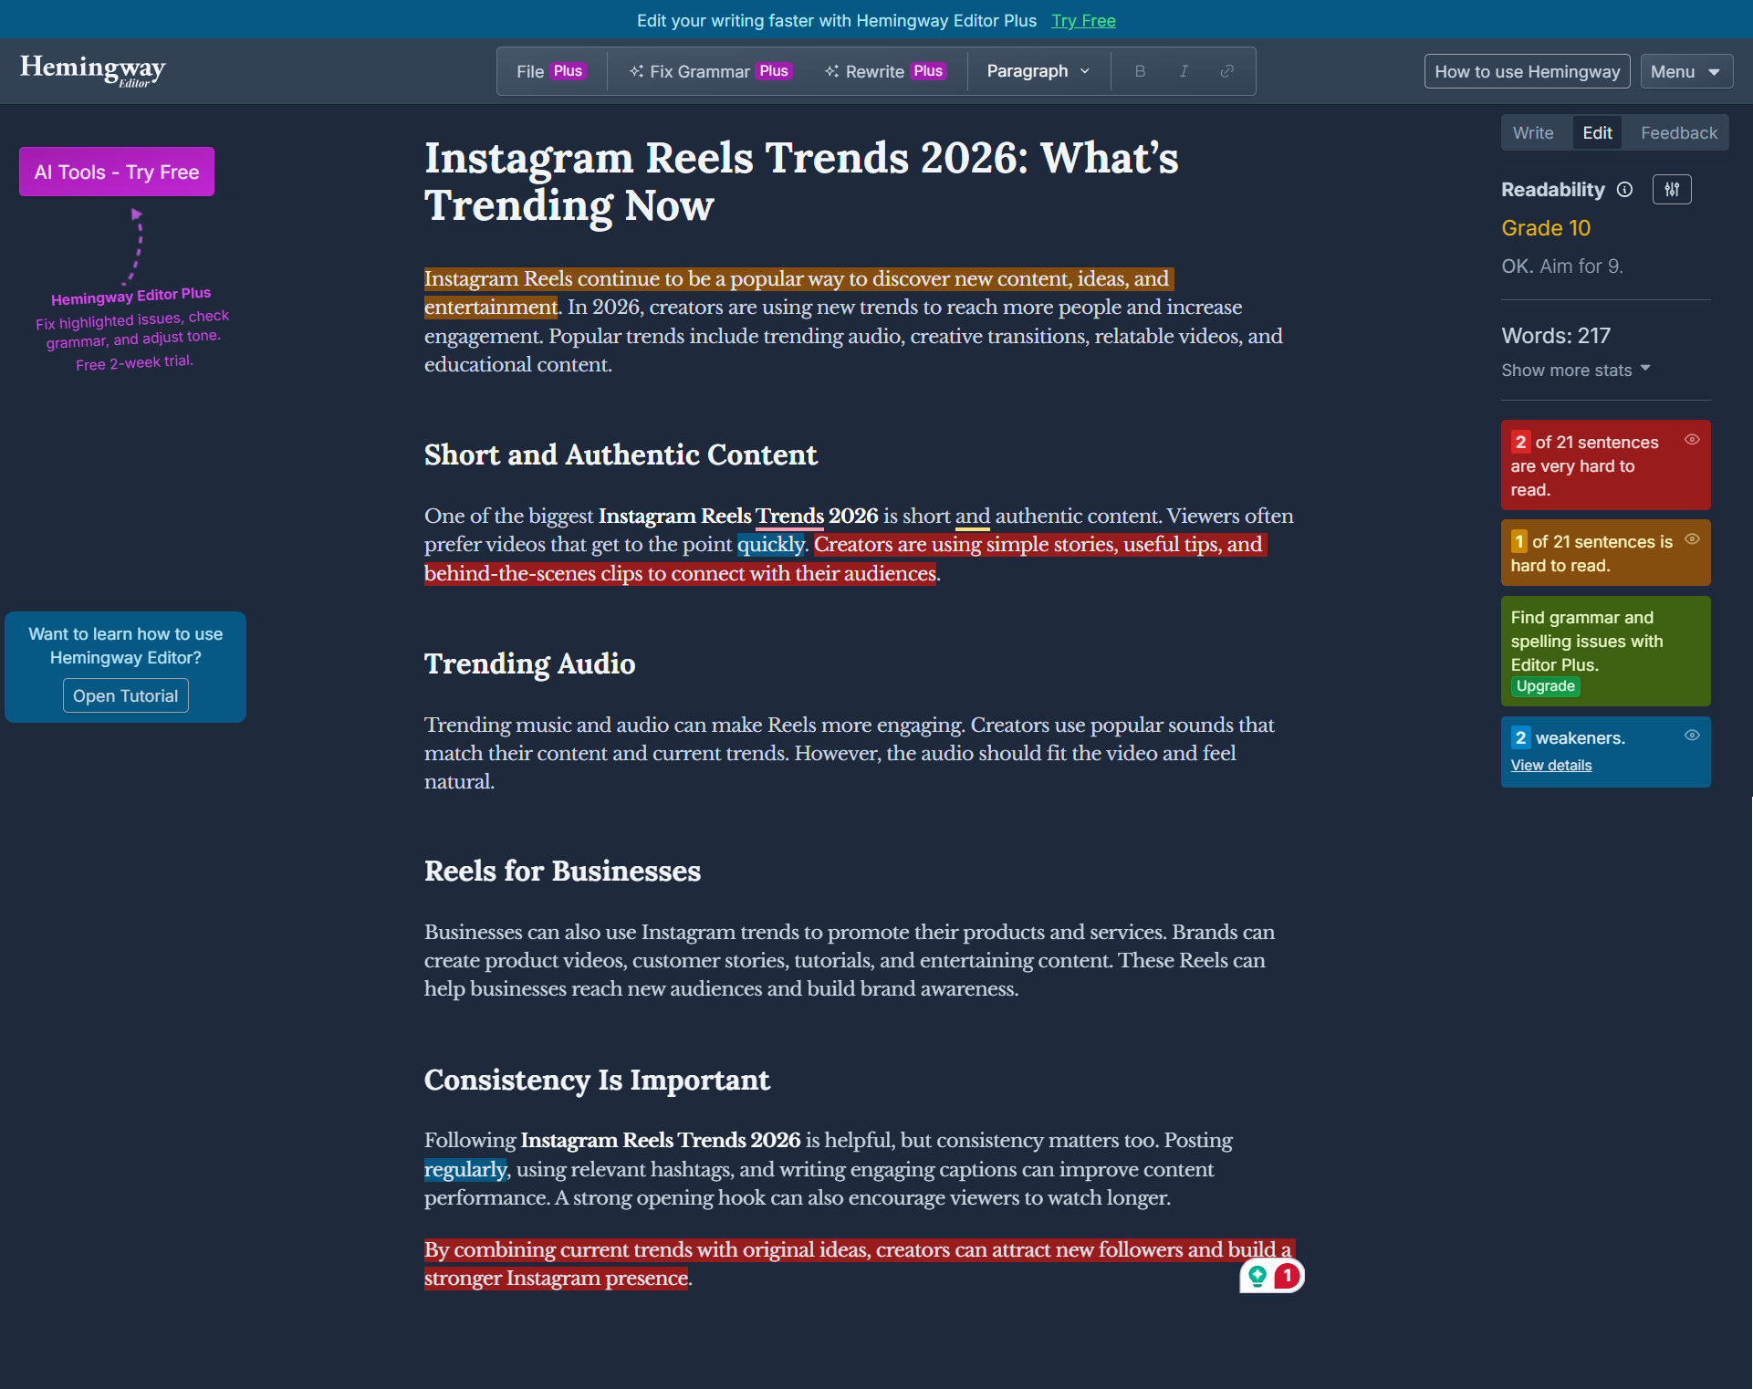
- Decide the ideal content length for a blog post targeting the keyword 'best budget smartphones in India' by analyzing the top 3 Google search results. Write down the word count for each and suggest an optimal length for your own post.<br><br><em><strong>Hint:</strong> Use a browser extension or online tool to count words on each page.</em>

After analyzing the top 3 Google results, their content lengths range from approximately 1,500 to 3,500 words. The average is around 2,600 words. Therefore, I would target 2,500–3,000 words for my blog post targeting “best budget smartphones in India.” This length should provide enough detail to compete with existing results while maintaining useful and readable content.

- Create a simple content refresh plan for a Zomato-style restaurant listing page. List 3 specific actions you would take to update the content and explain why each is important for SEO.

1. Update restaurant details
Add the latest menu, prices, ratings, location, opening hours, and offers.
👉 SEO benefit: Fresh information makes the page more useful and relevant to Google and users.
2. Add local keywords
Use keywords like “best restaurants in Ahmedabad” and “restaurants near me.”
👉 SEO benefit: Helps the page rank higher for local searches.
3. Add FAQs and descriptions
Add simple restaurant descriptions and FAQs like “Does this restaurant offer delivery?”
👉 SEO benefit: Helps target more search queries and gives users useful information.
In short: Update information + add local keywords + add FAQs = fresh and SEO-friendly content.

